DIS-Arc-Pipe-Sioux-Montana-Billings

• Large original black steatite (soapstone) stone pipe. Large beaver effigy.

• Most likely Plains Indian Sioux.

• Excellent condition. No breaks or repairs. Originates from a Billings Montana estate sale.

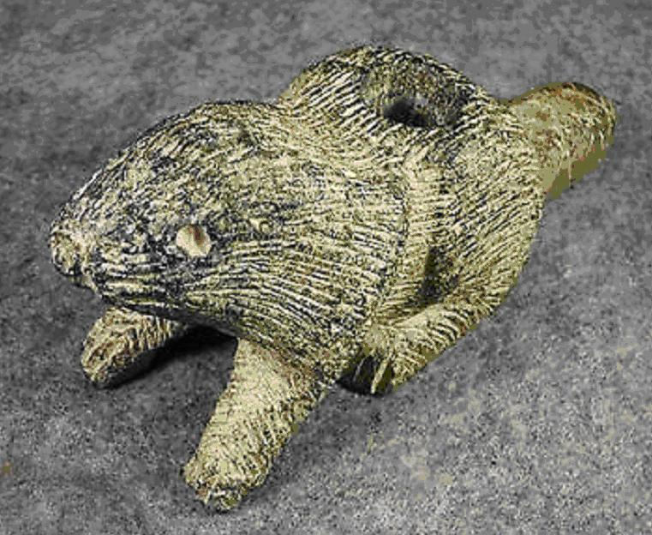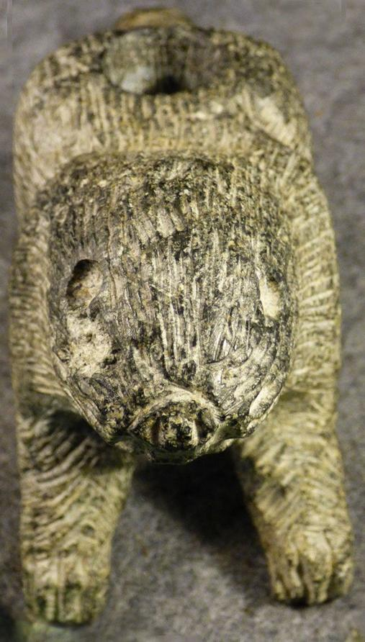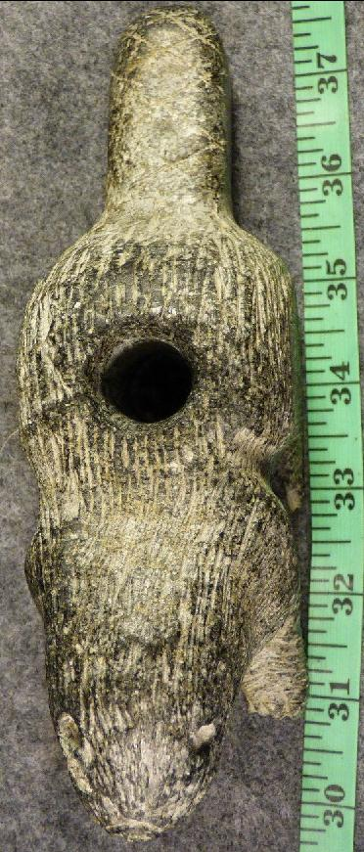

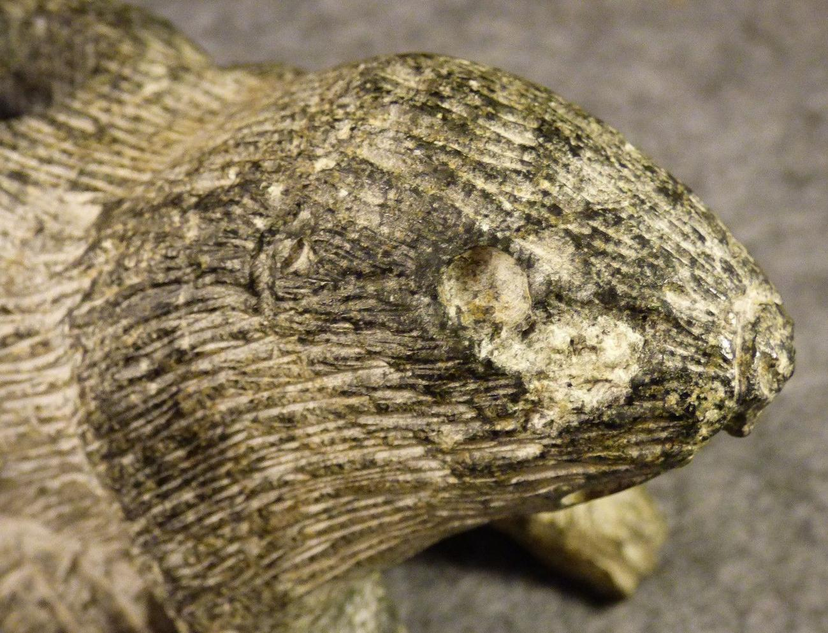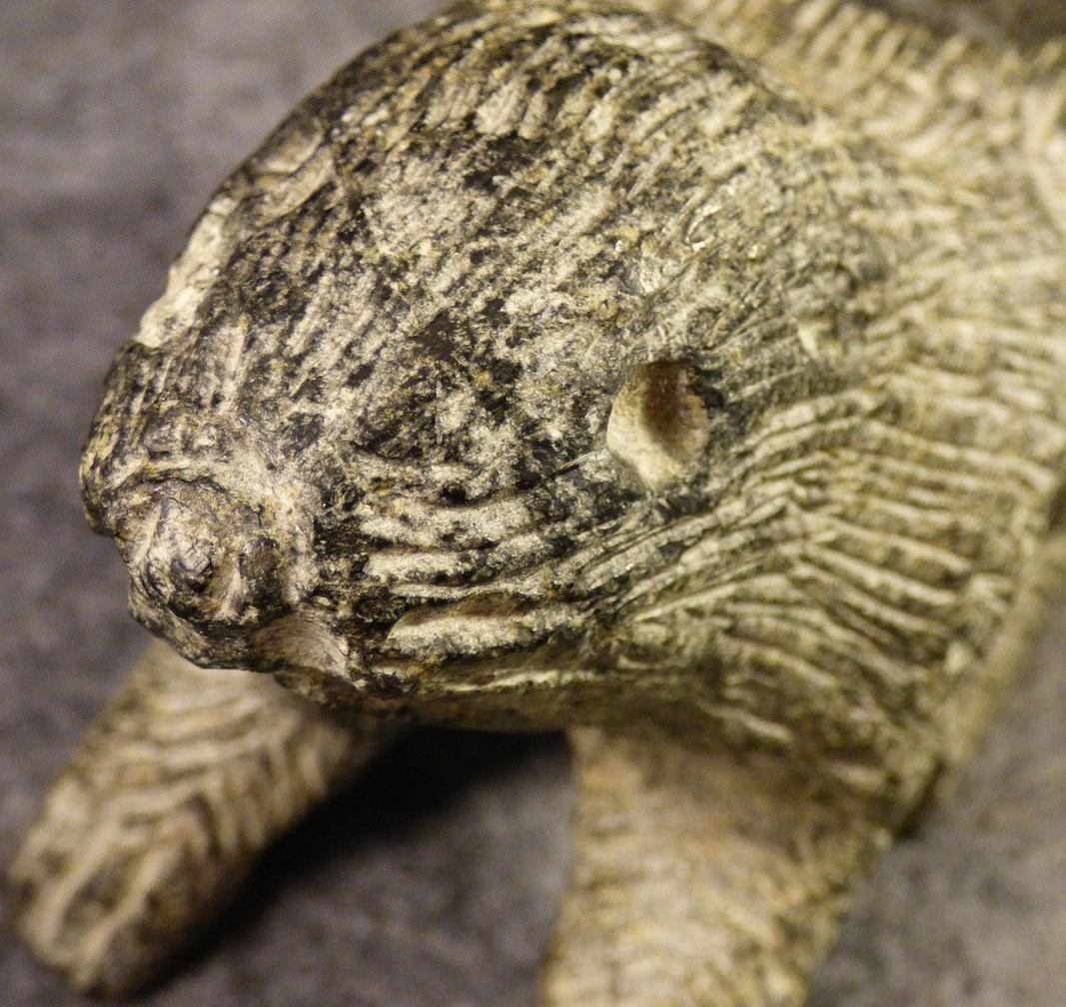

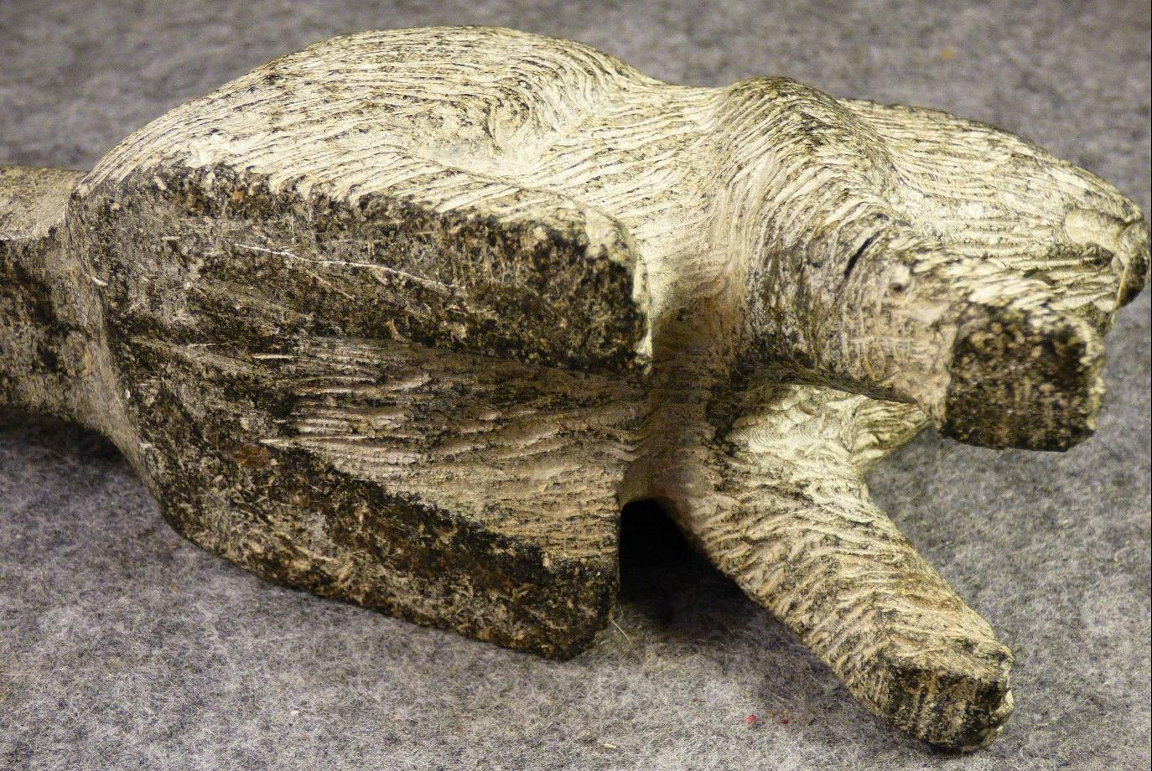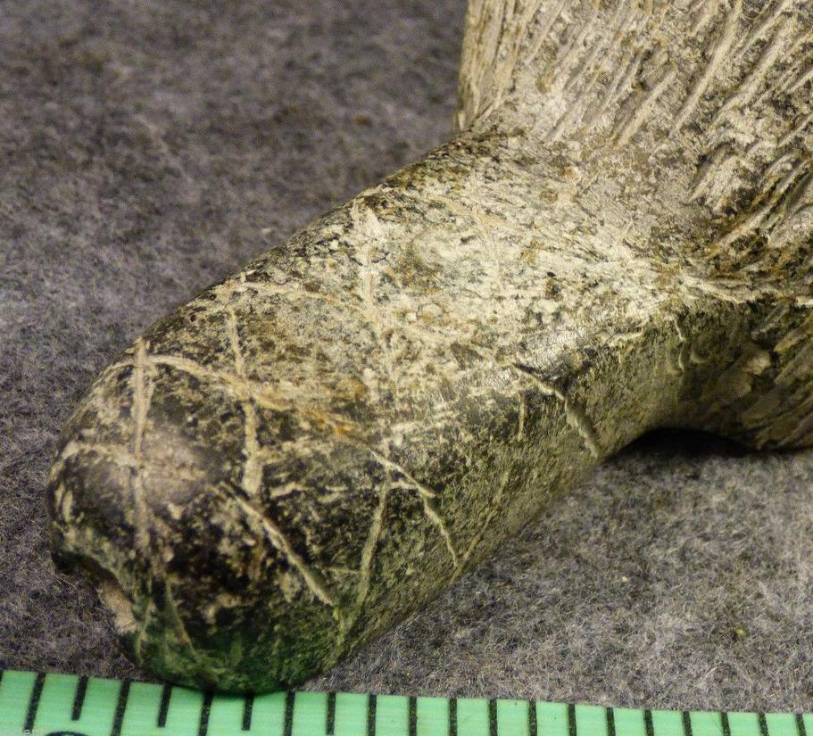

# Order details

## Sales order

Sold by [fortancient](http://myworld.ebay.com/fortancient) ( [410](http://feedback.ebay.com/ws/eBayISAPI.dll?ViewFeedback&userid=fortancient) )

### Delivery package 1 of 1

Estimated delivery Thursday, Apr 21, 2016 - Monday, Apr 25, 2016

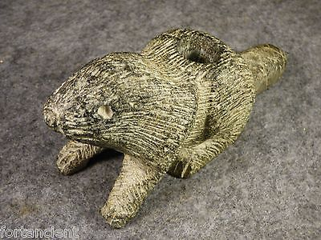

#### [Large Indian Beaver Platform Pipe Highly Detailed Sioux Black Steatite Stone OLD](http://www.ebay.com/itm/252352340993)

|  |  |
| --- | --- |
| Item price | $215.00 |
| Quantity | 1 |
| Item number | 252352340993 |
| Shipping service | USPS Priority Mail |

## Shipping address

## Order total

|  |  |
| --- | --- |
| Subtotal | $215.00 |
| Shipping | $9.45 |

**Total**

$224.45

Order placed on

Friday, Apr 15, 2016

Payment method

Credit card

Payment date

Friday, Apr 15, 2016